**PHP Exercise 14**

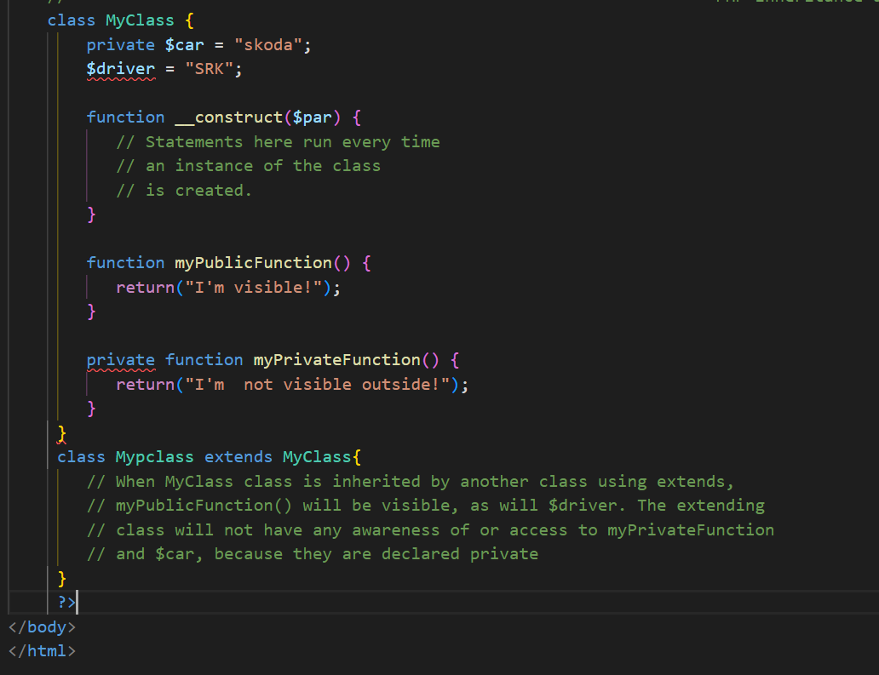

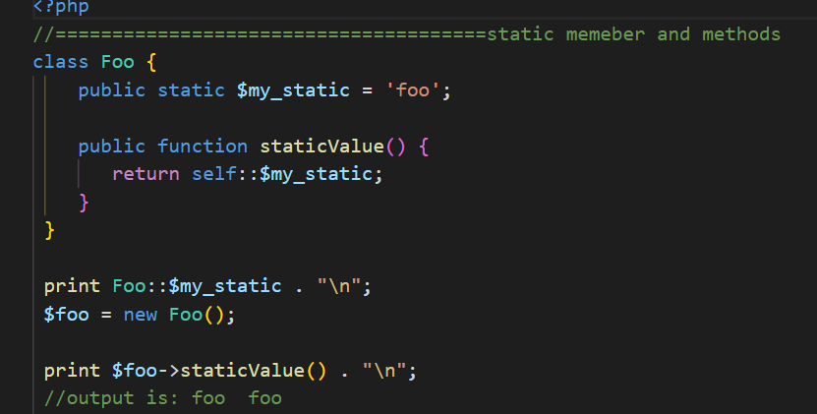

class Foo {

    public static $my_static = 'foo';

    public function staticValue() {

       return self::$my_static;

    }

 }

 print Foo::$my_static . "\n";

 $foo = new Foo();

 print $foo->staticValue() . "\n";

 //output is: foo  foo

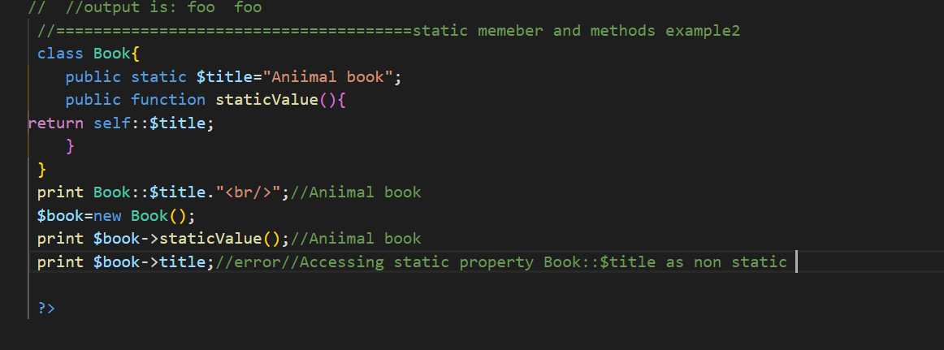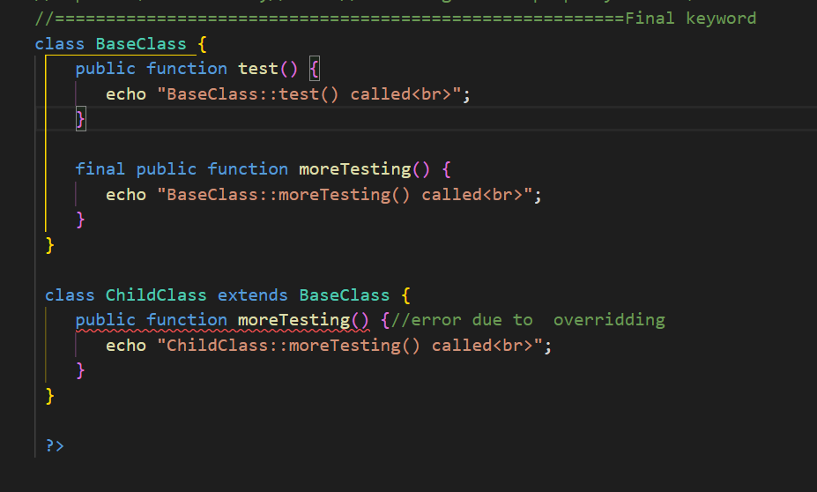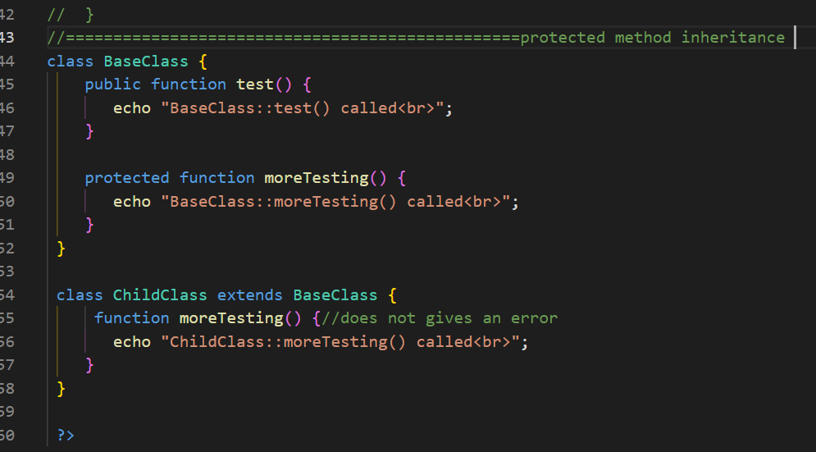

//================================================protected member inheritance

class BaseClass {

    protected $name="ajman";

    public function test() {

       echo "BaseClass::test() called<br>";

    }

    protected function moreTesting() {

       echo "BaseClass::moreTesting() called<br>";

    }

 }

 class ChildClass extends BaseClass {

  public  $name="kalim";

     function moreTesting() {//does not gives an error

       echo "ChildClass::moreTesting() ajman khan wazir junai<br>";

    }

 }

 $child=new ChildClass();

 echo $child->name."<br/>";

 echo $child->moreTesting()."<br/>";

 echo $child->test();

//output are given below

// kalim

// ChildClass::moreTesting() ajman khan wazir junai

// BaseClass::test() called

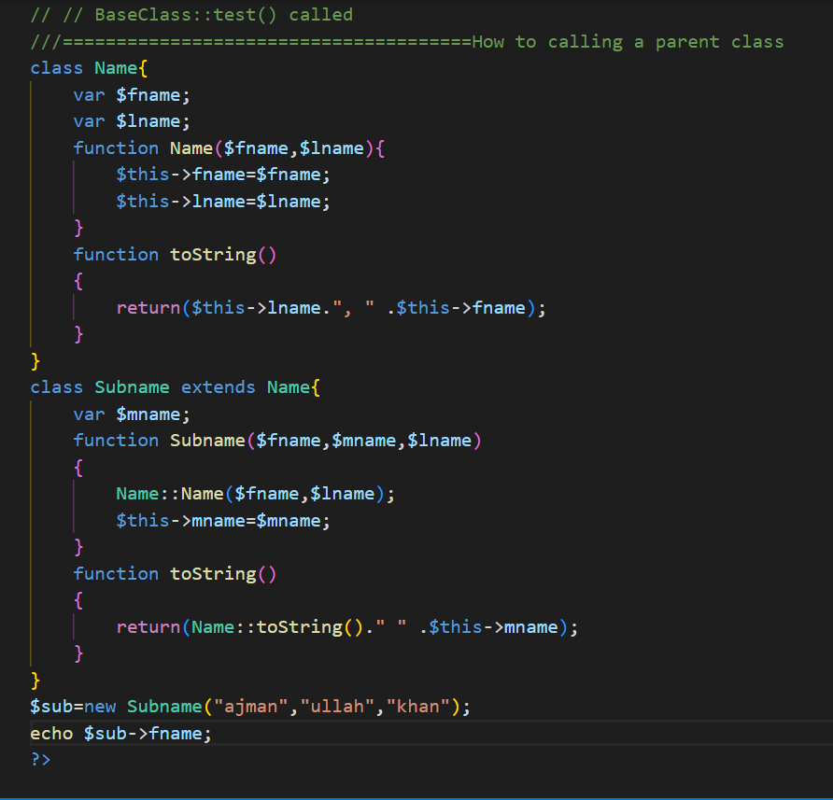

///======================================================================

**PHP Hour 10 chapter:**

$_server["MIBDIRS"]==D:/XAMP/php/extras/mibs  
$_server["MYSQL_HOME"]==\xampp\mysql\bin  
$_server["OPENSSL_CONF"]==D:/XAMP/apache/bin/openssl.cnf  
$_server["PHP_PEAR_SYSCONF_DIR"]==\xampp\php  
$_server["PHPRC"]==\xampp\php  
$_server["TMP"]==\xampp\tmp  
$_server["HTTP_HOST"]==localhost  
$_server["HTTP_CONNECTION"]==keep-alive  
$_server["HTTP_CACHE_CONTROL"]==max-age=0  
$_server["HTTP_SEC_CH_UA"]=="Opera";v="93", "Not/A)Brand";v="8", "Chromium";v="107"  
$_server["HTTP_SEC_CH_UA_MOBILE"]==?0  
$_server["HTTP_SEC_CH_UA_PLATFORM"]=="Windows"  
$_server["HTTP_UPGRADE_INSECURE_REQUESTS"]==1  
$_server["HTTP_USER_AGENT"]==Mozilla/5.0 (Windows NT 10.0; Win64; x64) AppleWebKit/537.36 (KHTML, like Gecko) Chrome/107.0.0.0 Safari/537.36 OPR/93.0.0.0  
$_server["HTTP_ACCEPT"]==text/html,application/xhtml+xml,application/xml;q=0.9,image/avif,image/webp,image/apng,*/*;q=0.8,application/signed-exchange;v=b3;q=0.9  
$_server["HTTP_SEC_FETCH_SITE"]==none  
$_server["HTTP_SEC_FETCH_MODE"]==navigate  
$_server["HTTP_SEC_FETCH_USER"]==?1  
$_server["HTTP_SEC_FETCH_DEST"]==document  
$_server["HTTP_ACCEPT_ENCODING"]==gzip, deflate, br  
$_server["HTTP_ACCEPT_LANGUAGE"]==en-US,en;q=0.9  
$_server["PATH"]==D:\oracle\product\10.2.0\db_2\bin;C:\oraclexe\app\oracle\product\11.2.0\server\bin;D:\java\java$javaScript\Scripts\;D:\java\java$javaScript\;C:\Program Files\Common Files\Oracle\Java\javapath;C:\Program Files\Python38\Scripts\;C:\Program Files\Python38\;C:\WINDOWS\system32;C:\WINDOWS;C:\Program Files\Microsoft SQL Server\Client SDK\ODBC\170\Tools\Binn\;C:\Program Files (x86)\Microsoft SQL Server\150\Tools\Binn\;C:\Program Files\Microsoft SQL Server\150\Tools\Binn\;C:\Program Files\Microsoft SQL Server\150\DTS\Binn\;C:\Program Files\dotnet\;C:\Users\amazon\Documents\dartsdk-windows-x64-release\dart-sdk\bin;C:\Users\amazon\Documents\dartsdk-windows-x64-release\dart-sdk\bin;C:\Program Files\Git\cmd;C:\Program Files (x86)\dotnet\;C:\Program Files (x86)\Microsoft SQL Server\150\DTS\Binn\;C:\Program Files\MongoDB\Server\6.0\bin;C:\Program Files\PostgreSQL\15\bin;D:\XAMP\htdocs;C:\Users\amazon\AppData\Local\Programs\Python\Python310\Scripts\;C:\Users\amazon\AppData\Local\Programs\Python\Python310\;C:\Program Files (x86)\Microchip\mplabc18\v3.47\mpasm;C:\Program Files (x86)\Microchip\mplabc18\v3.47\bin;C:\Users\amazon\AppData\Local\Microsoft\WindowsApps;C:\Program Files\Azure Data Studio\bin;C:\Users\amazon\.dotnet\tools;D:\softwarehouse\Visualcode\Microsoft VS Code\bin;C:\modeltech_6.5\win32;C:\Users\amazon\Documents\dartsdk-windows-x64-release\dart-sdk\bin;D:\java\PyCharm Community Edition 2022.1\bin;;D:\flutter\bin;C:\Program Files\Azure Data Studio\bin;C:\Program Files (x86)\MongoDB Atlas CLI\  
$_server["SystemRoot"]==C:\WINDOWS  
$_server["PATHEXT"]==.COM;.EXE;.BAT;.CMD;.VBS;.VBE;.JS;.JSE;.WSF;.WSH;.MSC  
$_server["WINDIR"]==C:\WINDOWS  
$_server["SERVER_SIGNATURE"]==

Apache/2.4.48 (Win64) OpenSSL/1.1.1l PHP/8.0.10 Server at localhost Port 80

$_server["SERVER_SOFTWARE"]==Apache/2.4.48 (Win64) OpenSSL/1.1.1l PHP/8.0.10  
$_server["SERVER_NAME"]==localhost  
$_server["SERVER_ADDR"]==::1  
$_server["SERVER_PORT"]==80  
$_server["REMOTE_ADDR"]==::1  
$_server["DOCUMENT_ROOT"]==D:/XAMP/htdocs  
$_server["REQUEST_SCHEME"]==http  
$_server["CONTEXT_PREFIX"]==  
$_server["CONTEXT_DOCUMENT_ROOT"]==D:/XAMP/htdocs  
$_server["SERVER_ADMIN"]==postmaster@localhost  
$_server["SCRIPT_FILENAME"]==D:/XAMP/htdocs/index5.php  
$_server["REMOTE_PORT"]==49755  
$_server["GATEWAY_INTERFACE"]==CGI/1.1  
$_server["SERVER_PROTOCOL"]==HTTP/1.1  
$_server["REQUEST_METHOD"]==GET  
$_server["QUERY_STRING"]==  
$_server["REQUEST_URI"]==/index5.php  
$_server["SCRIPT_NAME"]==/index5.php  
$_server["PHP_SELF"]==/index5.php  
$_server["REQUEST_TIME_FLOAT"]==1669732932.6839  
$_server["REQUEST_TIME"]==1669732932

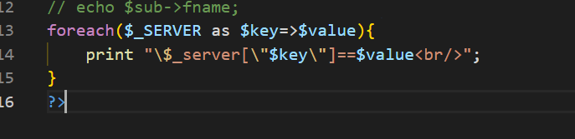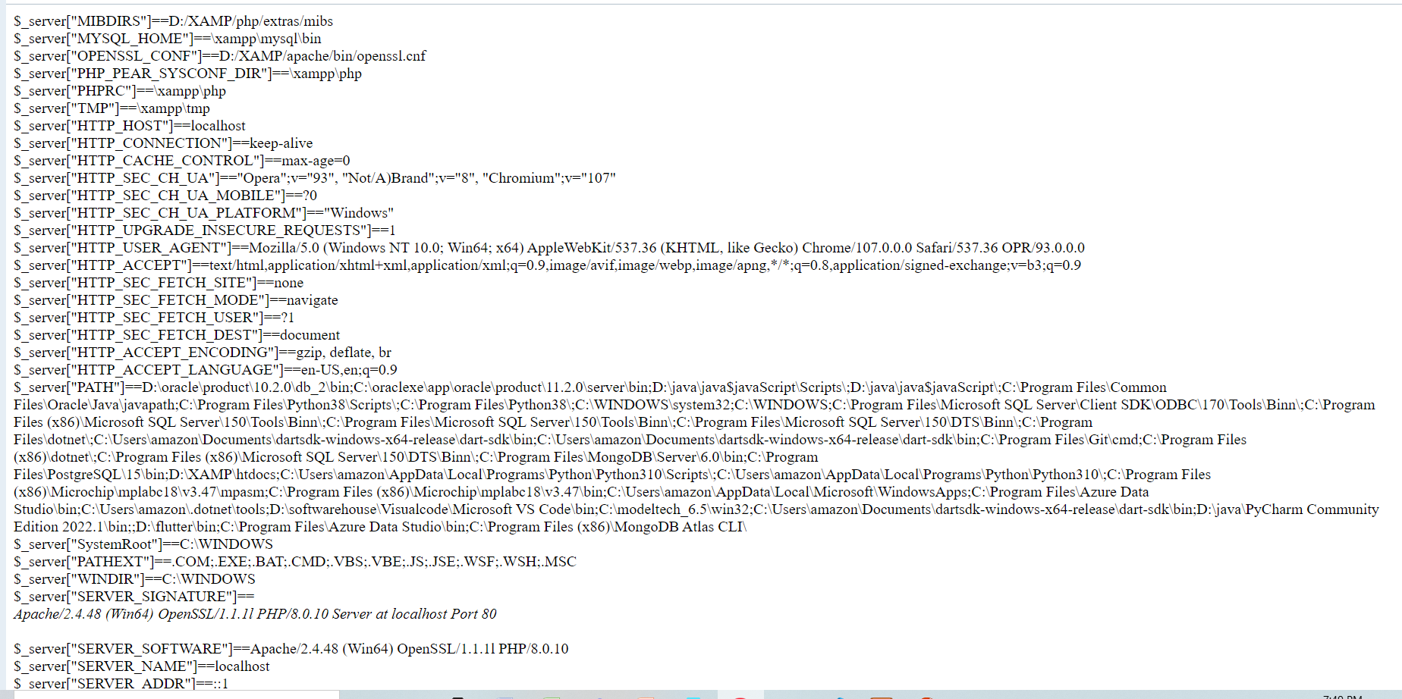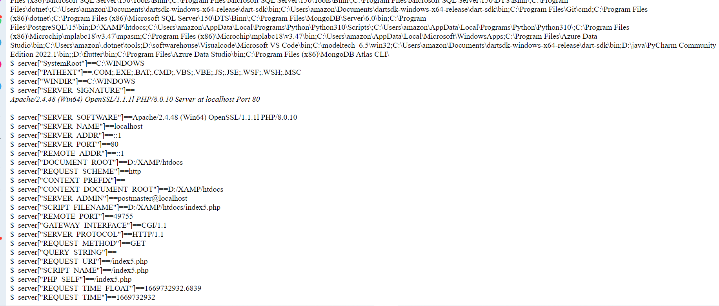

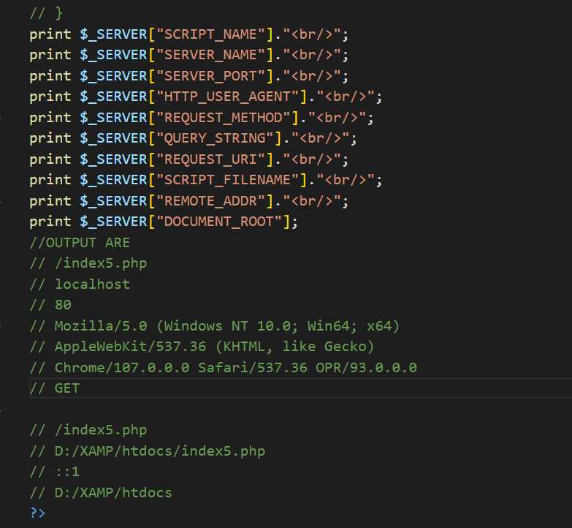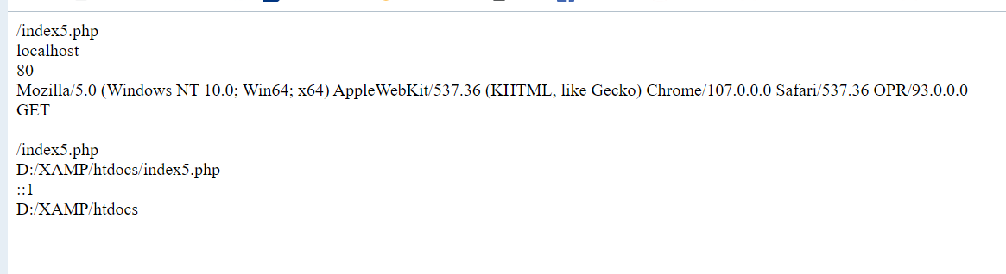

print $_SERVER["SCRIPT_NAME"]."<br/>";

print $_SERVER["SERVER_NAME"]."<br/>";

print $_SERVER["SERVER_PORT"]."<br/>";

print $_SERVER["HTTP_USER_AGENT"]."<br/>";

print $_SERVER["REQUEST_METHOD"]."<br/>";

print $_SERVER["QUERY_STRING"]."<br/>";

print $_SERVER["REQUEST_URI"]."<br/>";

print $_SERVER["SCRIPT_FILENAME"]."<br/>";

print $_SERVER["REMOTE_ADDR"]."<br/>";

print $_SERVER["DOCUMENT_ROOT"];

//OUTPUT ARE

// /index5.php

// localhost

// 80

// Mozilla/5.0 (Windows NT 10.0; Win64; x64)

// AppleWebKit/537.36 (KHTML, like Gecko)

// Chrome/107.0.0.0 Safari/537.36 OPR/93.0.0.0

// GET

// /index5.php

// D:/XAMP/htdocs/index5.php

// ::1

// D:/XAMP/htdocs

//========================================type casting

// $a=11.2;

// $b=(int)$a;

// echo $a."<br/>";//11.2

// echo $b."<br/>";//11

//======================================gettype()

// $n=100;

// if(gettype($n)=="integer")

// {

//     $number=$n;

//     echo "This is an integer which is:  {$n}";

// }

// else{

//     echo "this is an integer";

// }

//output :

//This is an integer which is: 100

//========================================settype()

// $n=100;

// if(settype($n,"integer"))

// {

//     echo "Conversion succesdded integer ";

// }

// else{

//     echo "this is an integer";

//     //output: Conversion succesdded integer

// }

//=========================================isset and unset()

// $n=100;

// if(isset($n))

// {

//     echo "this will print ";

// }

// else{

//     echo "<script>alert(Error)</script>";

// }

// //this will print

//example of unset ======================================

// $n=100;

// unset($n);

// if(isset($n))

// {

//     echo "this will print ";

// }

// else{

//     echo "there is no value ";

// }

//output is:  there is no value

//=====================================empty()

// $n=100;

// unset($n);

// if(empty($n))

// {//true

//     echo "this will print ";

// }

// else{//false

//     echo "there is no value ";

// }

// //output: this will print

//=====================================is_function()

// $n=100;

// // echo is_integer($n);//1 true

// echo is_string($n);//false

///===================================is_value()

// $product="432BB";

// $i=intval($product);

// echo $i;//432

//-===========================is_value()

// $product="432BB";

// $i=intval($product,16);

// print $i;//275131

//===================is_value()

// $product="43275";

// $i=intval($product,8);

// print $i;//18109

//====================is_value()

$product="1101100101";

$i=intval($product,2);

print $i;//869

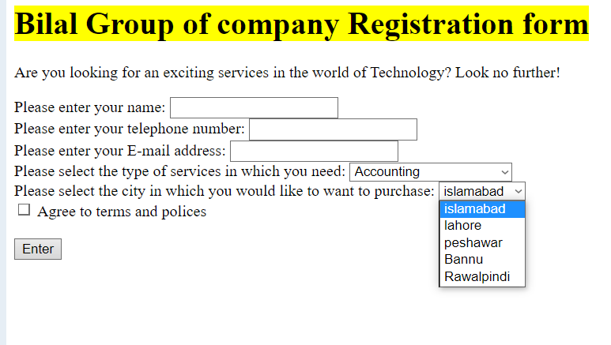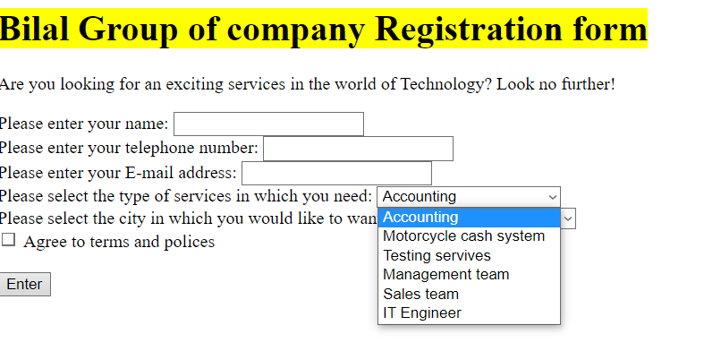

<HTML>

<!-- jobapp.html -->

 <BODY>

 <H1><mark>Bilal  Group of company Registration form</mark></H1>

 <P>Are you looking for an exciting services in the world of Technology?

 Look no further!

 </P>

 <FORM NAME='frmJobApp' METHOD="post" ACTION="jobapp_action.php">

 Please enter your name:

 <INPUT NAME="applicant" TYPE="text"><BR>

 Please enter your telephone number:

 <INPUT NAME="phone" TYPE="text"><BR>

 Please enter your E-mail address:

 <INPUT NAME="email" TYPE="text"><BR>

 Please select the type of services in which you need:

 <SELECT NAME="position">

 <OPTION VALUE="acounting all services avalaible ">Accounting</OPTION>

 <OPTION VALUE="Motorcycle cash system available">Motorcycle cash system</OPTION>

 <OPTION VALUE="Testing Qualified staff">Testing servives</OPTION>

 <OPTION VALUE="Management Team ">Management team</OPTION>

 <OPTION VALUE="sales team member">Sales team</OPTION>

 <option value="NUST Engineer">IT Engineer</option>

 </SELECT><BR>

 Please select the city in which you would like to want to purchase:

 <SELECT NAME="city">

 <OPTION VALUE="islamabad">islamabad</OPTION>

 <OPTION VALUE="lahore">lahore</OPTION>

 <OPTION VALUE="peshawar">peshawar</OPTION>

 <OPTION VALUE="Bannu">Bannu</OPTION>

 <OPTION VALUE="Rawalpindi">Rawalpindi</OPTION>

 </SELECT><BR>

 <INPUT NAME="avail" TYPE="checkbox"> Agree to terms and polices<BR><BR>

 <INPUT NAME="enter" TYPE="submit" VALUE="Enter">

 </FORM>

 </BODY>

</HTML>

////////////////////////////////////////////

<HTML>

<!-- jobapp_action.php -->

 <BODY>

 <?php

 if(isset($_POST['applicant'],$_POST['phone'],$_POST['email'],$_POST['position'],

 $_POST['city'])) {

    $applicant=$_POST['applicant'];

    $phone=$_POST['phone'];

    $email=$_POST['email'];

    $position=$_POST['position'];

    $city=$_POST['city'];

    echo $applicant;

    echo "<br/>";

    echo $phone;

    echo "<br/>";

    echo $email;

    echo "<br/>";

    echo $position;

    echo "<br/>";

    echo $city;

    echo "<br/>";

 }

 else{

    echo "something is missing";

 }

 ?>

 </BODY>

</HTML>

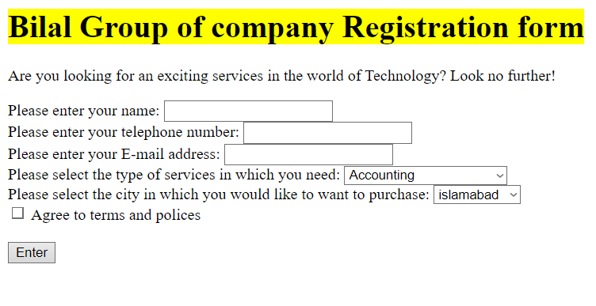

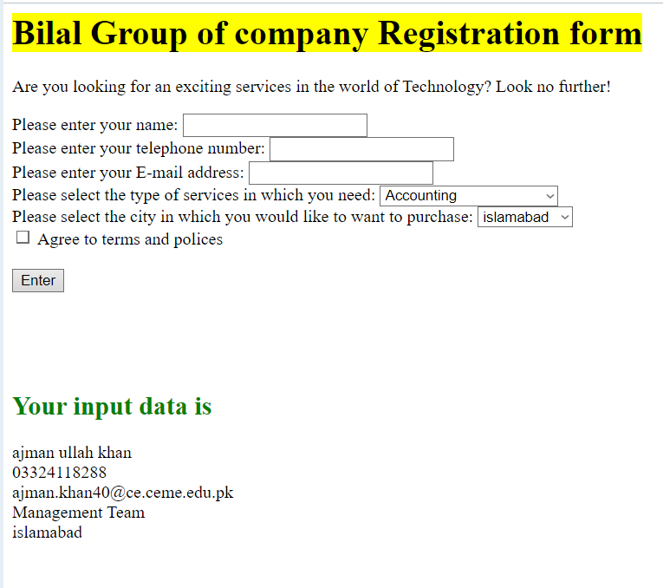

///////////////////////////////////////////////////////

<HTML>

<!-- jobapp.html -->

 <BODY>

 <H1><mark>Bilal  Group of company Registration form</mark></H1>

 <P>Are you looking for an exciting services in the world of Technology?

 Look no further!

 </P>

 <FORM NAME='frmJobApp' METHOD="post" ACTION="<?php htmlspecialchars($_SERVER["REQUEST_METHOD"]=="PHP_SELF"); ?>">

 Please enter your name:

 <INPUT NAME="applicant" TYPE="text"><BR>

 Please enter your telephone number:

 <INPUT NAME="phone" TYPE="text"><BR>

 Please enter your E-mail address:

 <INPUT NAME="email" TYPE="text"><BR>

 Please select the type of services in which you need:

 <SELECT NAME="position">

 <OPTION VALUE="acounting all services avalaible ">Accounting</OPTION>

 <OPTION VALUE="Motorcycle cash system available">Motorcycle cash system</OPTION>

 <OPTION VALUE="Testing Qualified staff">Testing servives</OPTION>

 <OPTION VALUE="Management Team ">Management team</OPTION>

 <OPTION VALUE="sales team member">Sales team</OPTION>

 <option value="NUST Engineer">IT Engineer</option>

 </SELECT><BR>

 Please select the city in which you would like to want to purchase:

 <SELECT NAME="city">

 <OPTION VALUE="islamabad">islamabad</OPTION>

 <OPTION VALUE="lahore">lahore</OPTION>

 <OPTION VALUE="peshawar">peshawar</OPTION>

 <OPTION VALUE="Bannu">Bannu</OPTION>

 <OPTION VALUE="Rawalpindi">Rawalpindi</OPTION>

 </SELECT><BR>

 <INPUT NAME="avail" TYPE="checkbox"> Agree to terms and polices<BR><BR>

 <INPUT NAME="enter" TYPE="submit" VALUE="Enter">

 </FORM>

 <br>

 <br>

 <br>

 <h2 style="color: green;">Your input data is </h2>

 </BODY>

 </HTML>

 <?php

 if(isset($_POST['applicant'],$_POST['phone'],$_POST['email'],$_POST['position'],

 $_POST['city'])) {

    $applicant=$_POST['applicant'];

    $phone=$_POST['phone'];

    $email=$_POST['email'];

    $position=$_POST['position'];

    $city=$_POST['city'];

    echo $applicant;

    echo "<br/>";

    echo $phone;

    echo "<br/>";

    echo $email;

    echo "<br/>";

    echo $position;

    echo "<br/>";

    echo $city;

    echo "<br/>";

 }

 else{

    echo "something is missing";

 }

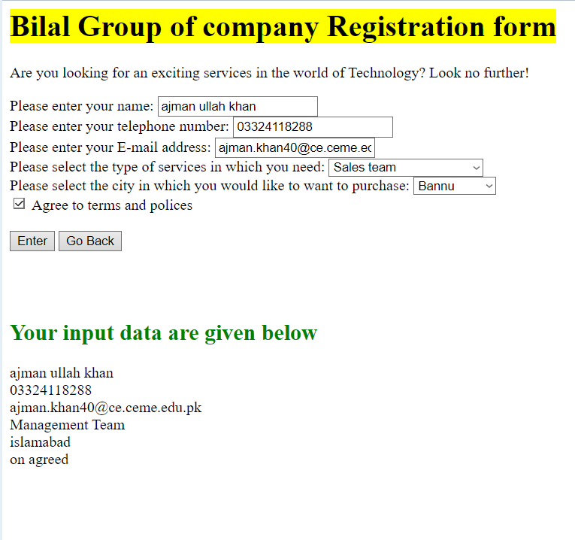

<HTML>

<!-- jobapp.html -->

 <BODY>

 <H1><mark>Bilal  Group of company Registration form</mark></H1>

 <P>Are you looking for an exciting services in the world of Technology?

 Look no further!

 </P>

 <FORM NAME='frmJobApp' METHOD="post" ACTION="<?php  htmlspecialchars($_SERVER["REQUEST_METHOD"]=="PHP_SELF"); ?>">

 Please enter your name:

 <INPUT NAME="applicant" TYPE="text"><BR>

 Please enter your telephone number:

 <INPUT NAME="phone" TYPE="text"><BR>

 Please enter your E-mail address:

 <INPUT NAME="email" TYPE="text"><BR>

 Please select the type of services in which you need:

 <SELECT NAME="position">

 <OPTION VALUE="acounting all services avalaible ">Accounting</OPTION>

 <OPTION VALUE="Motorcycle cash system available">Motorcycle cash system</OPTION>

 <OPTION VALUE="Testing Qualified staff">Testing servives</OPTION>

 <OPTION VALUE="Management Team ">Management team</OPTION>

 <OPTION VALUE="sales team member">Sales team</OPTION>

 <option value="NUST Engineer">IT Engineer</option>

 </SELECT><BR>

 Please select the city in which you would like to want to purchase:

 <SELECT NAME="city">

 <OPTION VALUE="islamabad">islamabad</OPTION>

 <OPTION VALUE="lahore">lahore</OPTION>

 <OPTION VALUE="peshawar">peshawar</OPTION>

 <OPTION VALUE="Bannu">Bannu</OPTION>

 <OPTION VALUE="Rawalpindi">Rawalpindi</OPTION>

 </SELECT><BR>

 <INPUT NAME="avail" TYPE="checkbox"> Agree to terms and polices<BR><BR>

 <INPUT NAME="enter" TYPE="submit" VALUE="Enter">

 <INPUT TYPE="button" VALUE="Go Back" ONCLICK="self.history.back()";>

 </FORM>

 <br>

 <br>

 <h2 style="color:green ;">Your input data are given below </h2>

 </BODY>

 </HTML>

 <?php

 if(isset($_POST['applicant'],$_POST['phone'],$_POST['email'],$_POST['position'],

 $_POST['city'])) {

    $applicant=$_POST['applicant'];

    $phone=$_POST['phone'];

    $email=$_POST['email'];

    $position=$_POST['position'];

    $city=$_POST['city'];

    $avail=$_POST['avail'];

    echo $applicant;

    echo "<br/>";

    echo $phone;

    echo "<br/>";

    echo $email;

    echo "<br/>";

    echo $position;

    echo "<br/>";

    echo $city;

    echo "<br/>";

    echo $avail."   agreed";

    echo "<br/>";

 }

 else{

    echo "something is missing";

 }

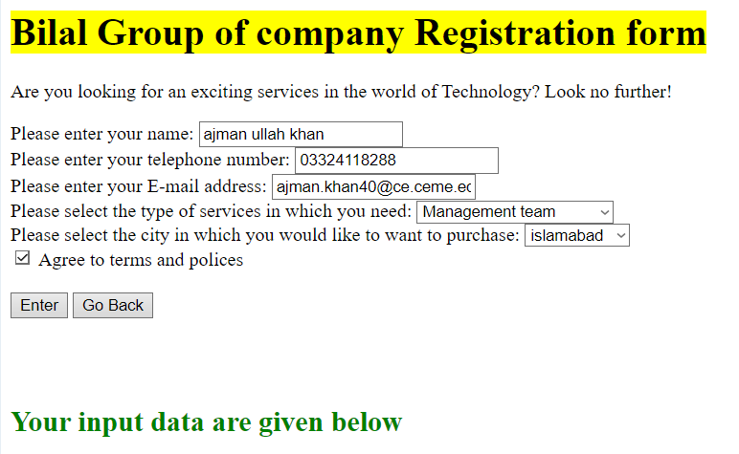

////////////////////=====================================================================

//========================================type casting

// $a=11.2;

// $b=(int)$a;

// echo $a."<br/>";//11.2

// echo $b."<br/>";//11

//======================================gettype()

// $n=100;

// if(gettype($n)=="integer")

// {

//     $number=$n;

//     echo "This is an integer which is:  {$n}";

// }

// else{

//     echo "this is an integer";

// }

//output :

//This is an integer which is: 100

//========================================settype()

// $n=100;

// if(settype($n,"integer"))

// {

//     echo "Conversion succesdded integer ";

// }

// else{

//     echo "this is an integer";

//     //output: Conversion succesdded integer

// }

//=========================================isset and unset()

// $n=100;

// if(isset($n))

// {

//     echo "this will print ";

// }

// else{

//     echo "<script>alert(Error)</script>";

// }

// //this will print

//example of unset ======================================

// $n=100;

// unset($n);

// if(isset($n))

// {

//     echo "this will print ";

// }

// else{

//     echo "there is no value ";

// }

//output is:  there is no value

//=====================================empty()

// $n=100;

// unset($n);

// if(empty($n))

// {//true

//     echo "this will print ";

// }

// else{//false

//     echo "there is no value ";

// }

// //output: this will print

//=====================================is_function()

// $n=100;

// // echo is_integer($n);//1 true

// echo is_string($n);//false

///===================================is_value()

// $product="432BB";

// $i=intval($product);

// echo $i;//432

//-===========================is_value()

// $product="432BB";

// $i=intval($product,16);

// print $i;//275131

//===================is_value()

// $product="43275";

// $i=intval($product,8);

// print $i;//18109

//====================is_value()

$product="1101100101";

$i=intval($product,2);

print $i;//869

?>

